How to access the Intel DevCloud?

1. Go to the Intel Developer Cloud:

Link: <https://tinyurl.com/d4xxmkz8>

1. Graphical user interface, website

   Description automatically generatedClick the enroll button:
2. Graphical user interface, application

   Description automatically generatedCreate an Intel account
3. Graphical user interface, application, email

   Description automatically generatedEnter your information. After doing so, enter the verification code from the email registered in your account.
4. Graphical user interface, text, application

   Description automatically generatedEnter the following reason why you need to use the Developer Cloud. Use “student” as the type of user.
5. 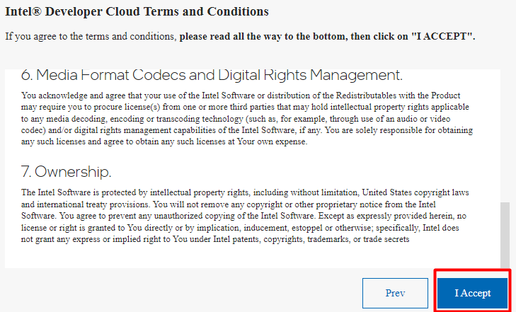Accept the terms and conditions:

1. Accept the terms and conditions:
2. Graphical user interface, text, application, email

   Description automatically generated Click Submit:
3. Graphical user interface, text, application

   Description automatically generatedGraphical user interface, text, application, email

   Description automatically generated You should see the following screen:
4. Graphical user interface, website

   Description automatically generated After loading, you should go back to the first screen. Click on Work with oneAPI.
5. Graphical user interface, application

   Description automatically generated Click on the Bare Metal Development “Get Started” button
6. Graphical user interface, application

   Description automatically generatedClick on “Click Here to Sign In”
7. Click on the File option, then move the cursor to New, and then click on the Terminal Option

git clone https://github.com/Goleys/classification_mod_workshop.git

1. Put the following command in the terminal:

1. Wait for more instructions!!!